## **Research on Google Maps integration into third party apps**

Ways to integrate a Google Maps API into our app:

* Location data for the Urban Sciences Building (a marker on a map)
  + Can also provide name, address, and other rich details like ratings, reviews, or contact information
* Get directions from user’s location to the Urban Sciences Building
  + Provides reliable directions between two markers on a map, and estimates for travel time and distance

Link to example usage of Google Maps API: <https://cloud.google.com/maps-platform/> shows example code of using Google Maps in a mobile app.

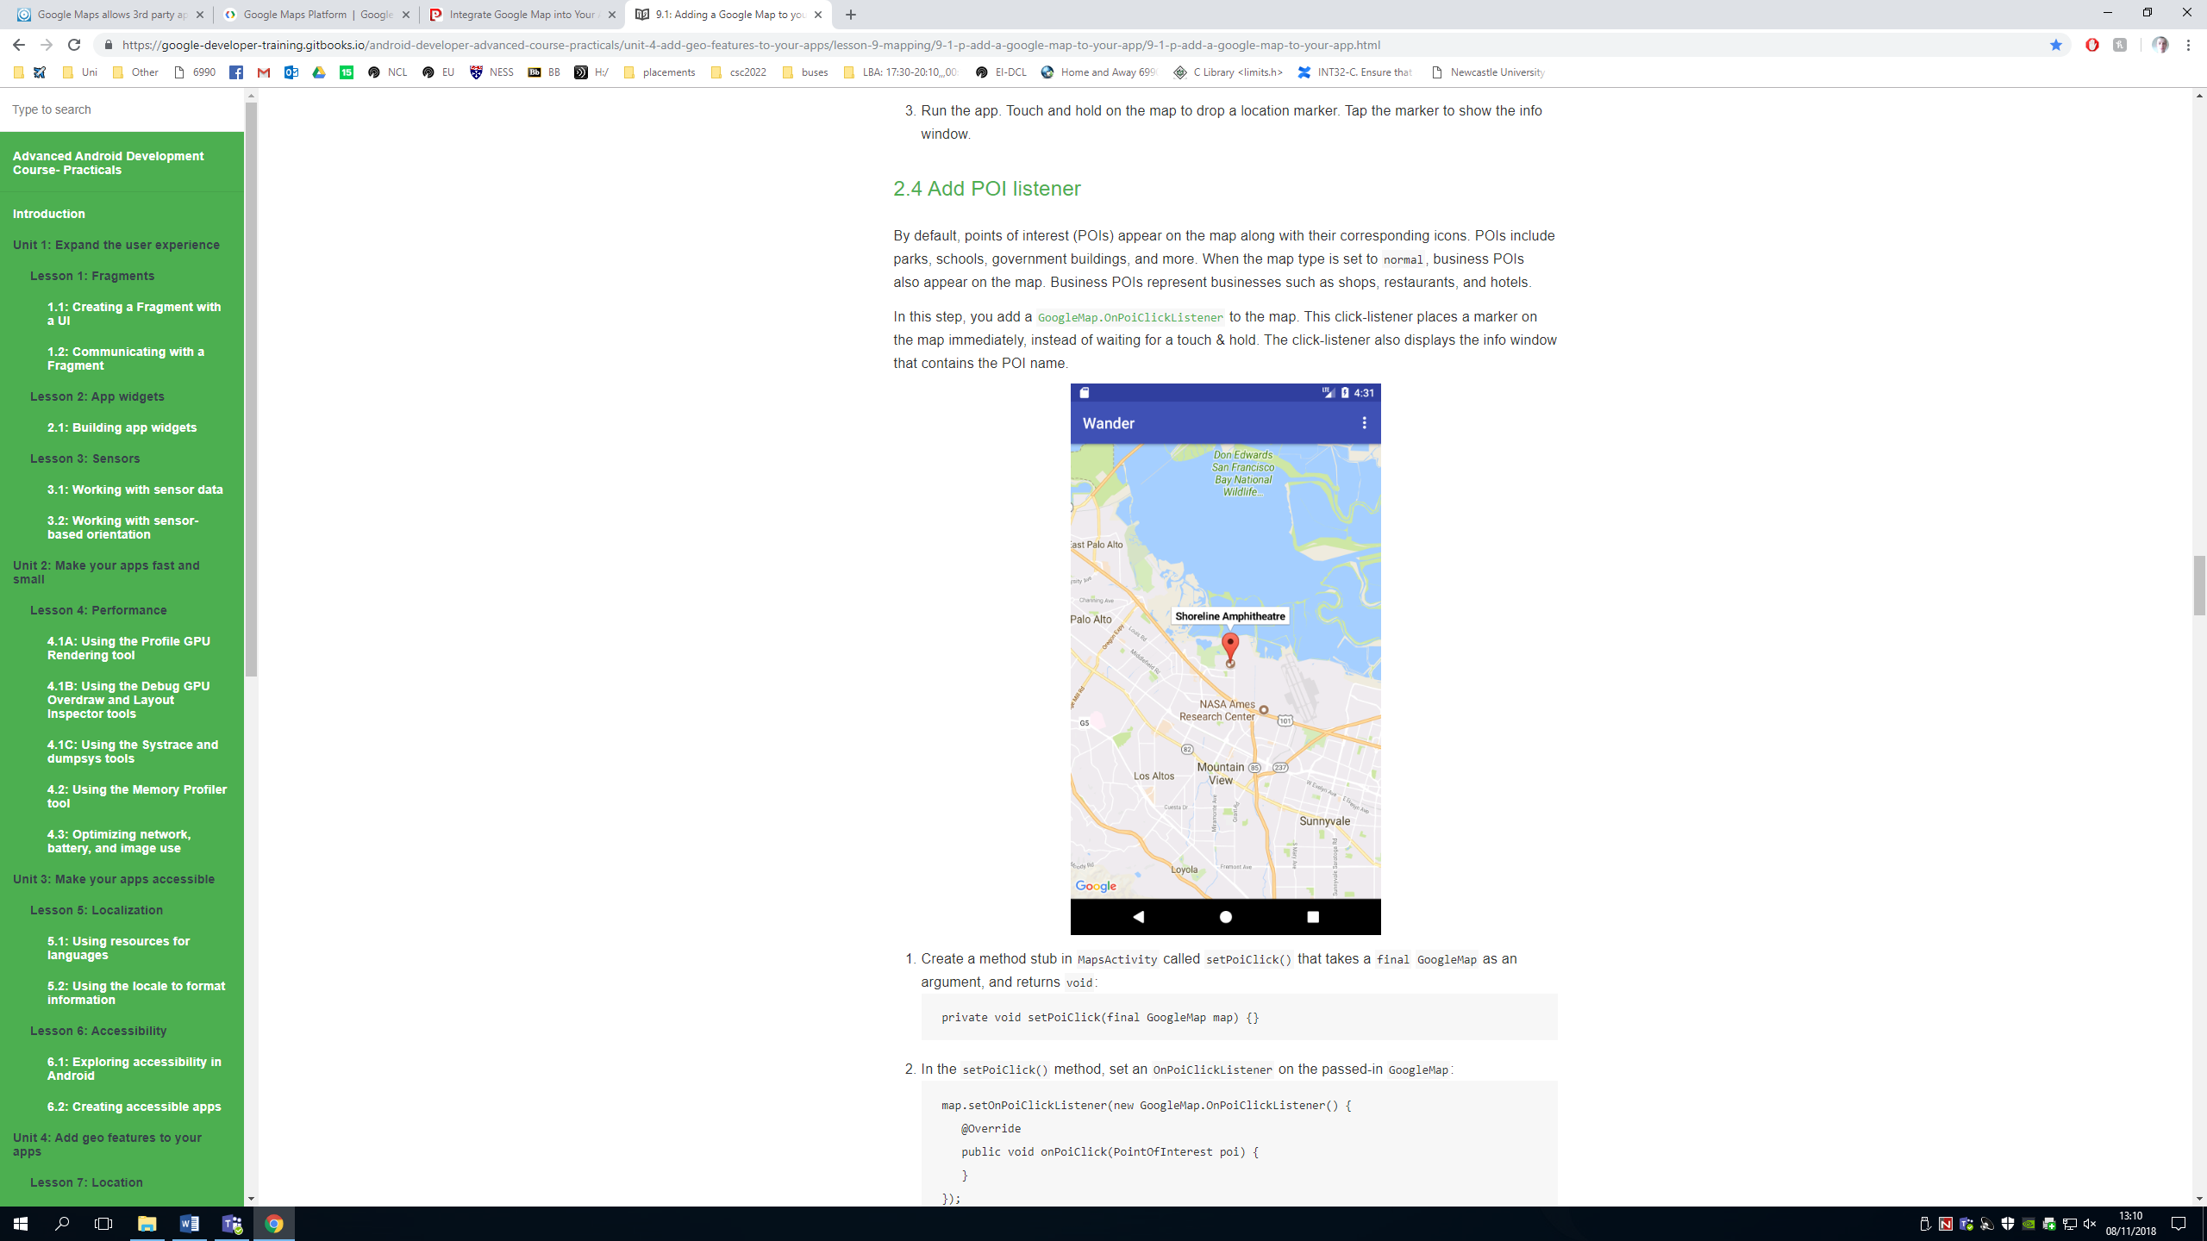Link to step-by-step guide on how to integrate Google Maps into a mobile app: <https://google-developer-training.gitbooks.io/android-developer-advanced-course-practicals/unit-4-add-geo-features-to-your-apps/lesson-9-mapping/9-1-p-add-a-google-map-to-your-app/9-1-p-add-a-google-map-to-your-app.html> includes information on adding different map types, changing the default map location and styling a map.

Image shows how a map may look in a mobile app

Also worth noting that if we require to use google maps for free in our mobile application then we must use the Developer Plan. The Developer Plan is free and may be used, given that the application based on Google Maps is free (!) to use for everyone (!). Maps used with the Developer Plan may contain advertising. <https://ubilabs.net/en/news/google-maps-apis-licensing-2016-04-21>

Other related websites:

<https://blogs.perficient.com/2017/09/20/integrate-google-map-into-your-app/>

<https://developers.google.com/maps/api-key-best-practices>

<https://developers.google.com/maps/faq>